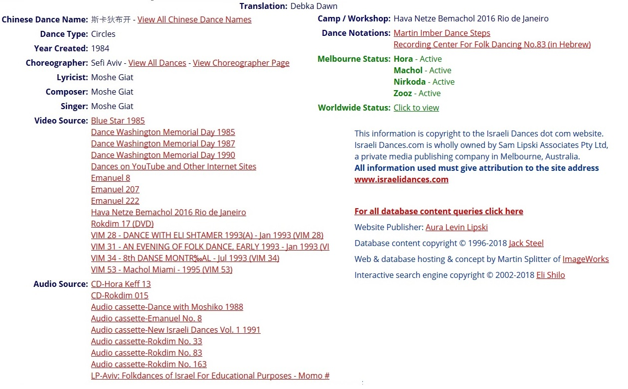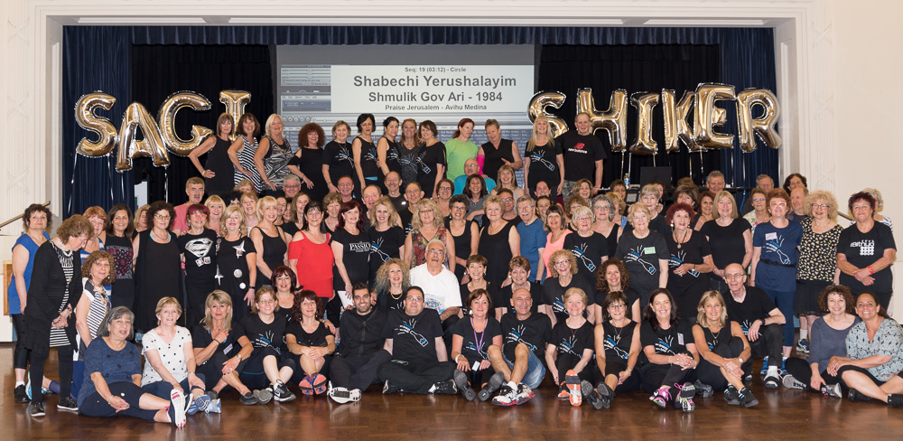Here’s what Aura has on this song in her database:www.israelidances.com. Those new to Israeli dance should take the time to visit Aura’s website which is the definitive website for English speaking participants of Israeli dance. Note: This is a copied page and the links are not active. Below, in the body of this discussion, we activate some of these links.

A quick determination as to whether this dance is still popularly played is to look at the Melbourne status. Melbourne is very active as far as Israeli dance is concerned and as you can see supports 4 Israeli dance classes weekly (we think). Readers of this web site are already familiar with the Zooz session which you can read about at [www.thediskcoordinator.com/melbourne.htm](http://www.thediskcoordinator.com/melbourne.htm). The picture that this paragraph surrounds was taken at the Nirkoda session during a workshop featuring Sagi Azran (bottom row) and Israel Shiker (circled). For those who keep track, Azran was the featured guest choreographer at Don Schillinger’s President Week workshop in 2017.

Here is a picture of workshop participants at a workshop sponsored by Zooz. In this picture the circle indicates Shmulik Gov Ari

The fact that all the Melbourne classes have this dance as active indicates that the dance is a standard in Israeli dancing.

Notice that one artist, Moshe Giat, is responsible for the music and lyrics as well as the singing. We believe Giat to be of Tunisian extraction. Giat has visited Tunisia to sing ancient Jewish Tunisian songs as the article below indicates. Listening to the music it’s obvious that Debka Shachar has an Arabic flavor. It would not be surprising if we found threads of traditional Tunisian music within its melodies.

Keep in mind that Aura’s database indicates **year created** as it pertains to the choreography. More research must ensue to determine when and from where (album for instance) the music originated.

As mentioned above, this article mentions Giat and his ties to the country of Tunisia.

**Every year hundreds if not thousands of Jewish pilgrims travel to Djerba island in Tunisia, where an ancient Synagogue is believed to contain a stone from the destroyed First Temple in Jerusalem. This year, controversy has come with them.**

**By** [**John Thorne, Correspondent**](https://www.csmonitor.com/World/Middle-East/2014/0518/In-Tunisia-an-ancient-Jewish-pilgrimage-controversy-and-hope) **May 18, 2014**

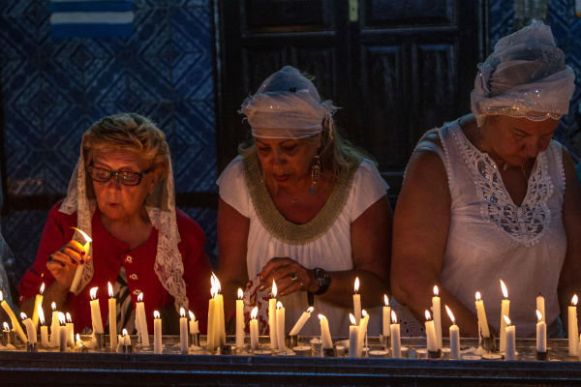Erriadh, Tunisia — Pilgrims were crowding into the sanctuary, votive candles were glowing under the arches, and a singer from Jerusalem named **Moshe Giat** was atop a low bench, leading the men in an old and rousing song in Hebrew that ended, “Hear, O Israel!”

Jerusalem? No. This scene took place in Tunisia, where about a thousand Jews are gathered this weekend for an annual Jewish pilgrimage and festival on the island of Djerba. The presence of Israeli visitors like Mr. Giat has become the focus of a sharp controversy among Tunisia’s political leaders.

On May 9, legislators at a raucous parliamentary hearing cited support for the Palestinian cause, opposition to Israel, and Israeli attacks on PLO figures in Tunisia in the 1980’s as grounds for removing two government ministers and reversing a recent decision to formalize procedures for Israelis visiting Tunisia, which does not have diplomatic relations with Israel. The government says the move will boost Tunisia’s struggling tourism industry by projecting a message of openness.

The polemic is quintessentially Tunisian, combining fears for an economy battered by the country’s 2011 revolution, evocations of the Arab world’s most enduring *cause célèbre*, and the tumultuous politics of an emerging democracy. For Tunisians, it’s also an occasion to weigh their country’s priorities.

**Ancient roots**

According to tradition, Jews fled from ancient Israel to Djerba bearing a stone from the temple following its destruction in 586 B.C. by the Babylonian king Nebuchadnezzar. Today the stone rests in the foundation of the La Ghriba synagogue.

Tunisia’s Jewish community has dwindled to about 1,000 since the mid-20th century as regional tensions over Israel and the prospect of jobs abroad led many to emigrate. But the La Ghriba pilgrimage for the Jewish festival of Lag Ba’omer has remained a big draw for Jews of diverse origins.

One is Mr. Giat, who is attending for the sixth time since 1992. After singing, he is seated at a courtyard table in a building beside the synagogue where food is being served and a band is in full swing, eating almonds with fellow Israeli Alan Debasc.

Mr. Debasc, a who owns a pizzeria in Rome and traveled on his Italian passport, recalls bigger crowds in years past. “Then came the intifada and Bin Laden, and everything changed,” he says.

In April 2002, a terrorist truck-bombing struck the La Ghriba synagogue, killing 21 people. Most were German tourists. Meanwhile**,** tensions over the 2000 Second Palestinian Intifada uprising had led Tunisia to close an overseas affairs office in Israel that that had provided entry permits for Israelis since opening in 1996**.** Yet then-president Zine El Abidine Ben Ali still wanted to reassure Western allies that Tunisia was friendly to Jews.

Israelis continued to visit Tunisia under an ad-hoc arrangement whereby they surrendered their passports to border police in exchange for temporary entry permits. That practice continued after Ben Ali’s 2011 overthrow.

**Cruise revolt**

Controversy erupted in March after police at La Goulette, near Tunis, barred 14 Israeli cruise ship passengers from going ashore on the grounds that they lacked proper travel documents. The cruise operator, Miami-based Norwegian Cruise Lines, then canceled stops in Tunisia, with other cruise lines reportedly following suit.

Amid fears that a reputation for discrimination might damage Tunisia’s tourist season, the government scrambled to establish official entry procedures for Israeli passport-holders. New rules formalize the existing practice of exchanging passports for temporary entry permits

About 150 Israelis are attending this year’s pilgrimage, says René Trabelsi, a tour operator who is Jewish and handles most foreign visitors. “But we could have had more,” he says. “Some aren’t coming because they were afraid of being blocked. We could have 20,000 pilgrims, but it will require openness to Israel.”

Some politicians, however, condemn the steps to ease Israelis’ entry as a form of normalizing relations with Israel.

A communiqué adopted at the May 9 parliamentary hearing stopped short of calling for a no-confidence vote against tourism minister Amel Karboul and Minister Delegate for National Security Ridha Sfar, as about 80 of Tunisia’s 217 MP’s had wanted. But it committed Tunisia to rejecting normal ties with Israel.

It’s impossible to gauge Tunisians’ views on Israeli tourists, but many hold negative views of Israel’s government. Seventy-seven percent of Tunisians think that Israel opposes democracy in the Middle East, according to a July 2012 study by the Pew Research Center.

“Yes, Tunisia is in a difficult situation economically,” says Issam Chebbi, spokesman for the left-leaning Joumhouri party. “But how can we accept that our tourism should benefit at the cost of the Palestinians?”

He argues that Tunisia has a moral obligation to oppose Israel, citing the Israeli-Palestinian conflict and past Israeli attacks in Tunisia itself.

**IDF attack**

Monji Ben Khedija, a retired administrator for a wine-making cooperative, remembers vividly the morning in 1985 that Israeli fighter jets swooped down the Mediterranean and bombarded PLO headquarters near his house in Hammam Chott, a beachside suburb of Tunis where the group was based from 1982 to 1991, killing dozens of Palestinians and Tunisians in what Israel said was retaliation for PLO attacks on Israelis.

Mr. Ben Khedija rushed home to find that PLO men had taken his bed sheets for burial shrouds. His daughter later married a PLO member, and he supports the Palestinian cause. Yet he also wants Israeli tourists to help Tunisia’s economy.

“I don’t like to make enemies,” he says. “I prefer to make friends.”

A spirit of friendship was palpable in the La Ghriba synagogue on Friday, perhaps most strikingly across religious lines.

Shortly after Giat finished singing, Mourad and Olfa Boumaiza and their young daughter Baya, who are Muslims, entered the sanctuary with Monique Hayoum, a childhood friend of Mr. Boumaiza, who is Jewish. Together they left votive offerings by the temple stone in the form of eggs signed with their names, a La Ghriba tradition.

“Let officials from Palestine and Israel come here,”  says Yacoub Cohen, seated at a table nearby collecting cash offerings for the synagogue and dispensing receipts. “Let them see how Jews and Arabs can live together.”

The substitute instructor at Germantown on Feb 11th is going to teach this dance. Apparently one of the regular dancers has requested this. The choreography is not hard but there are a few tricks. The choreography is attributed to Sefi Aviv in 1984. Apparently, the dance was successful from its inception as it was a part of two workshops in 1985. There are plenty of examples of the dance on youtube and below are some links. The one with Ira Weisburg, taken during his world tour in 2013/2014 we find to be quite instructive.

* Here’s a link to Sefi Aviv teaching the dance: <http://musicvideoswiz.com/song/Moshe%20Giat/Debka%20Shachar/>
* A link to Ira Weisburg teaching this: <https://www.youtube.com/watch?v=n_hiwinQl0I>
* <https://www.youtube.com/watch?v=7sgPnsiZFGU> as done in North Carolina
* <https://www.youtube.com/watch?v=_bDHgYHgczg> Porch Dancing
* As done in China <https://www.youtube.com/watch?v=sxBd-mVgAdo>
* <https://www.youtube.com/watch?v=YQ9Mv7rZwmI> as done by an all female group
* Debkas are supposed to be done low to the ground as far as feet are concerned. You can “Israeli” this up as you can see in this video: <https://www.youtube.com/watch?v=XB9bEVQSJ-0>

Associated with Aura’s database is one by Jack Steele. As legend has it, Jack migrated to Melbourne, Australia in his capacity as an engineer and took up Israeli dance. No doubt the same features that attracted the editors of this web site to this type of dance, attracted Jack. Sometime early in the ‘90s, in order to make his own learning of the dances easier, he created his own language to interpret the dance steps.

He created a web site holding this information and later that decade, as we are to understand, teamed up with Aura Lipski to create the whole site. We understand that Jack still has a hand in the database development of this “aussie database”.

Martin Imber has attempted to translate Jack’s language of dance steps back into English. You can access his web site at <http://imber.com.au/> and follow the links. He was active in this during 2008/9. Below is a revised pictoral interpretation of Imber’s attempt at describing the choreography.

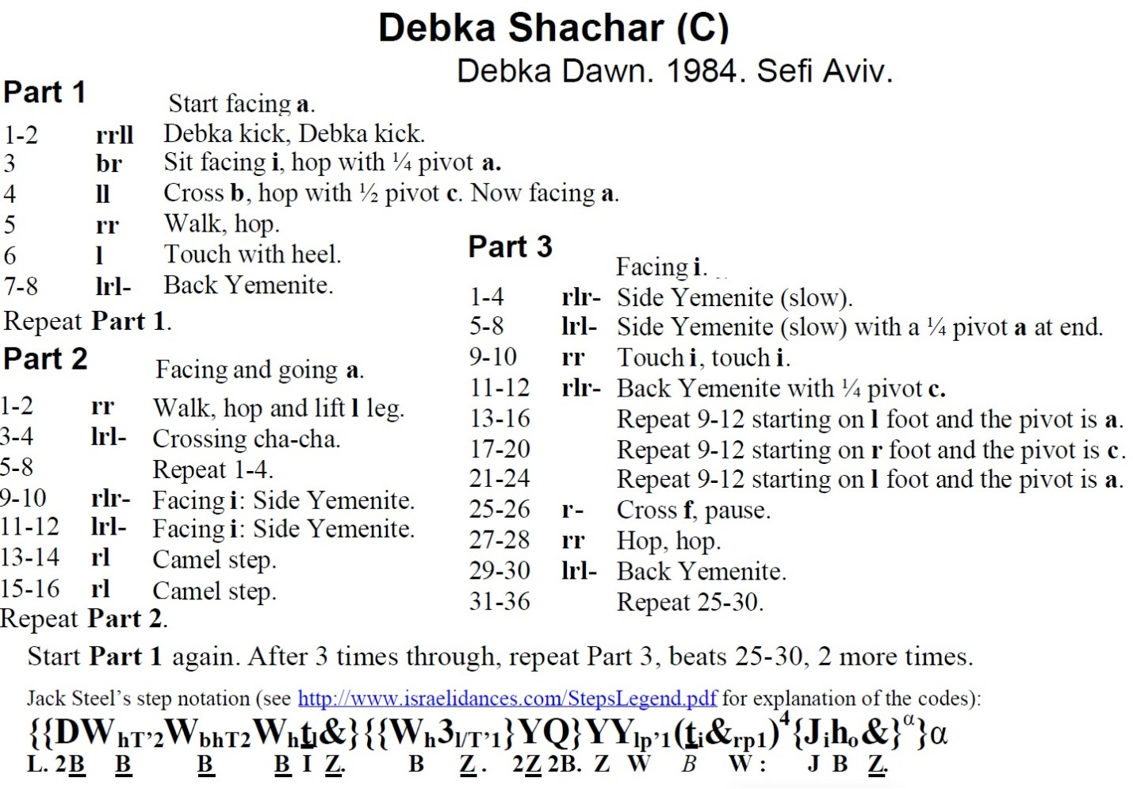

The link indicated above (which is not operable as this is a graphic) is [www.israelidances.com/StepsLegend.pdf](http://www.israelidances.com/StepsLegend.pdf)